**Assignment No:-27**

Name:-Suryawanshi Sangramsingh Sambhaji

Batch: - Delta - DCA (Java) 2024 Date:-12/6/2024

**Abstraction:**

**1. Write a Java program to create an abstract class Animal with an abstract method called sound(). Create subclasses Lion and Tiger that extend the Animal class and implement the sound() method to make a specific sound for each animal.**

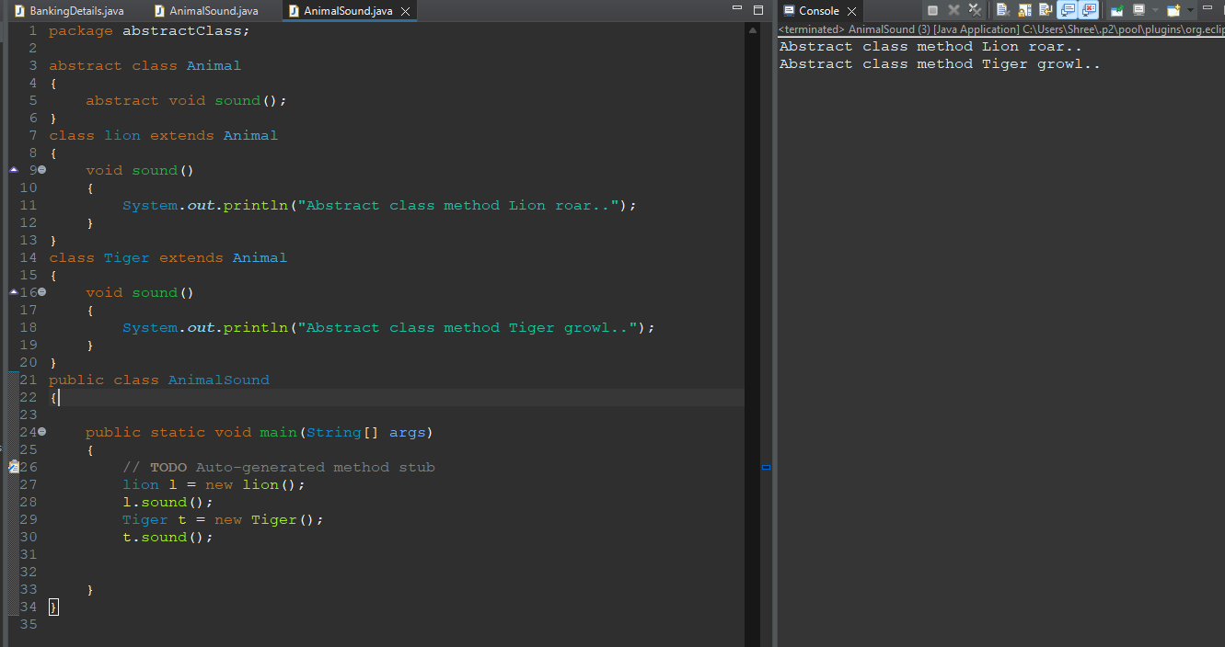

**2. Write a Java program to create an abstract class Shape with abstract methods calculateArea() and calculatePerimeter(). Create subclasses Circle and Triangle that extend the Shape class and implement the respective methods to calculate the area and perimeter of each shape.**

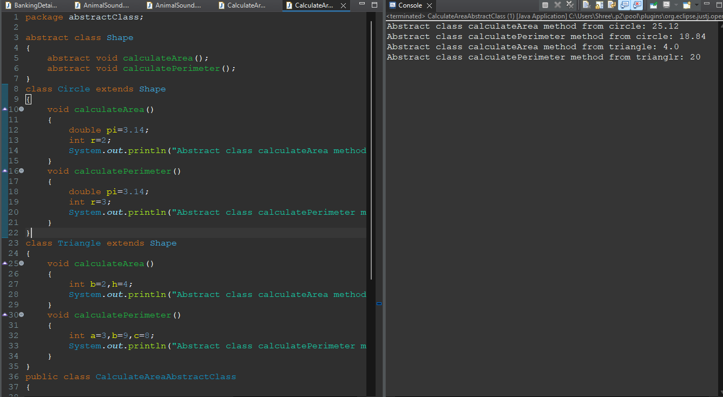 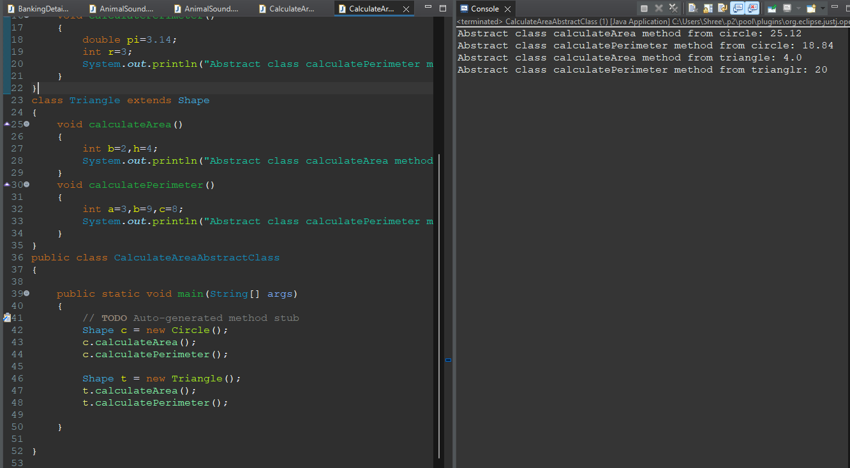

**3. Write a Java program to create an abstract class BankAccount with abstract methods deposit() and withdraw(). Create subclasses: SavingsAccount and CurrentAccount that extend the BankAccount class and implement the respective methods to handle deposits and withdrawals for each account type.**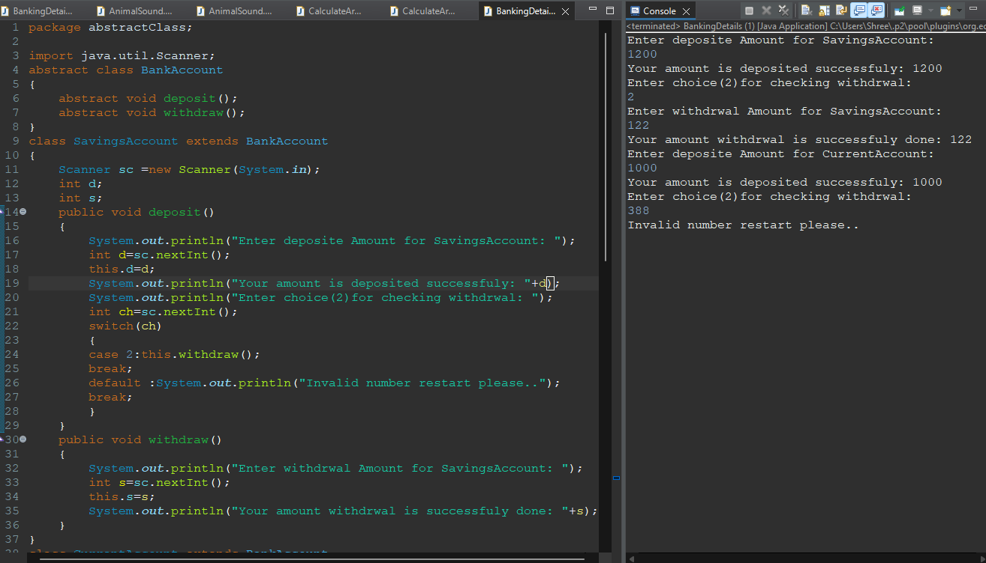 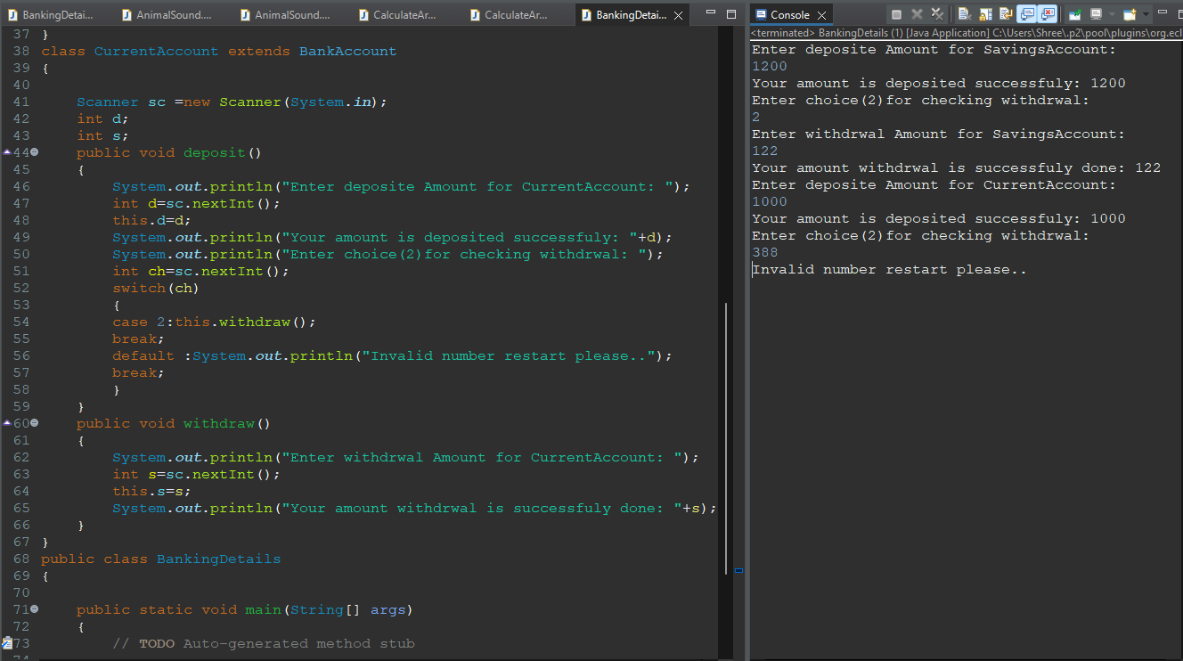

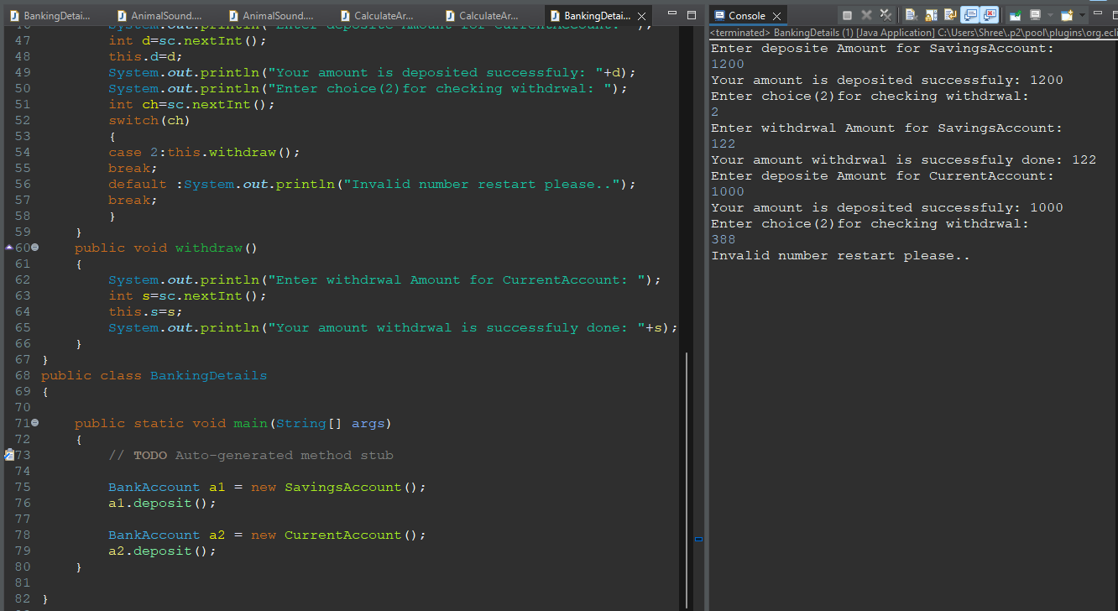

**4. Write a Java program to create an abstract class Animal with abstract methods eat() and sleep(). Create subclasses Lion, Tiger, and Deer that extend the Animal class and implement the eat() and sleep() methods differently based on their specific behavior.**

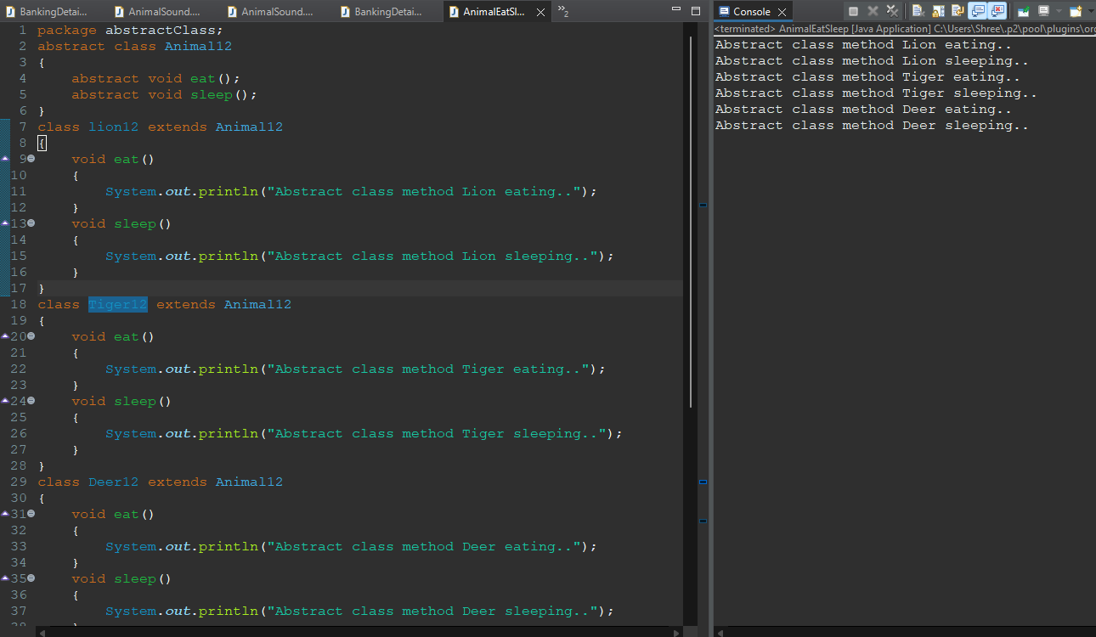

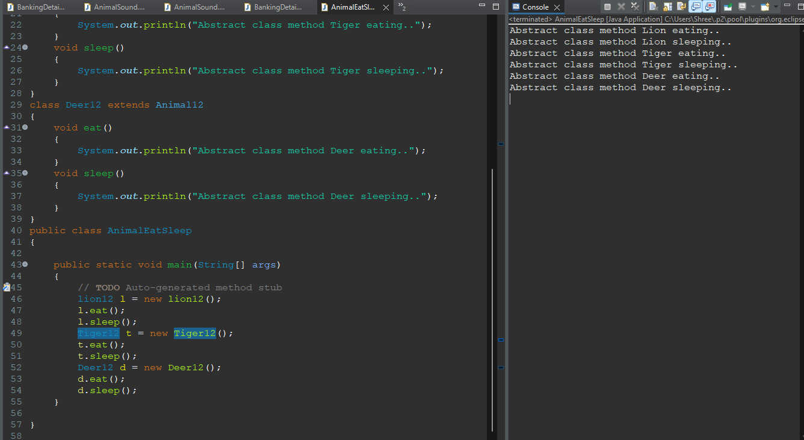

**5. Write a Java program to create an abstract class Employee with abstract methods calculateSalary() and displayInfo(). Create subclasses Manager and Programmer that extend the Employee class and implement the respective methods to calculate salary and display information for each role.**

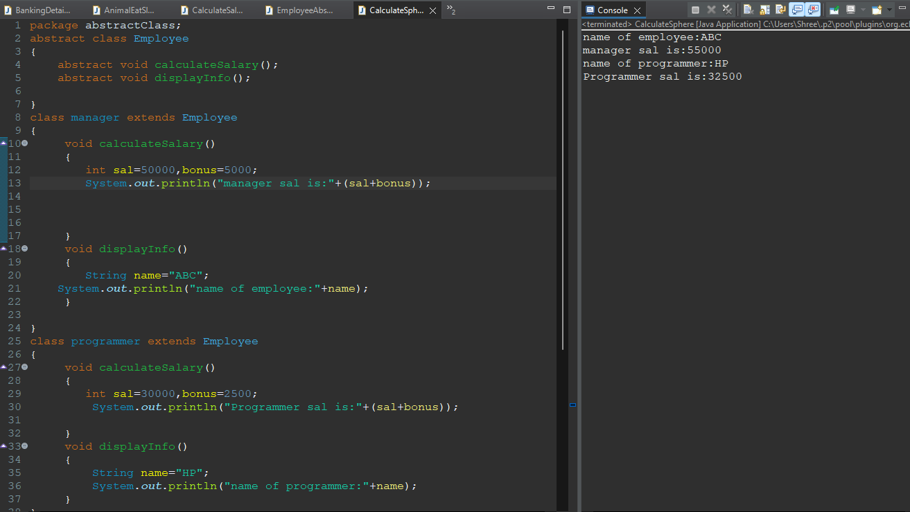

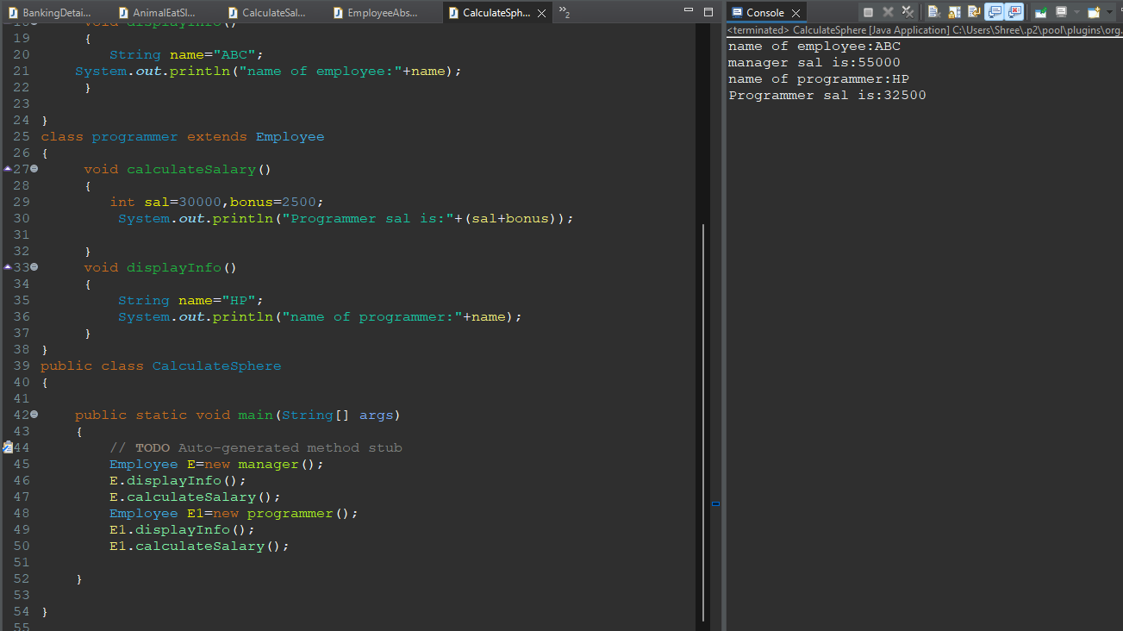

**6. Write a Java program to create an abstract class Shape3D with abstract methods calculateVolume() and calculateSurfaceArea(). Create subclasses Sphere and Cube that extend the Shape3D class and implement the respective methods to calculate the volume and surface area of each shape.**

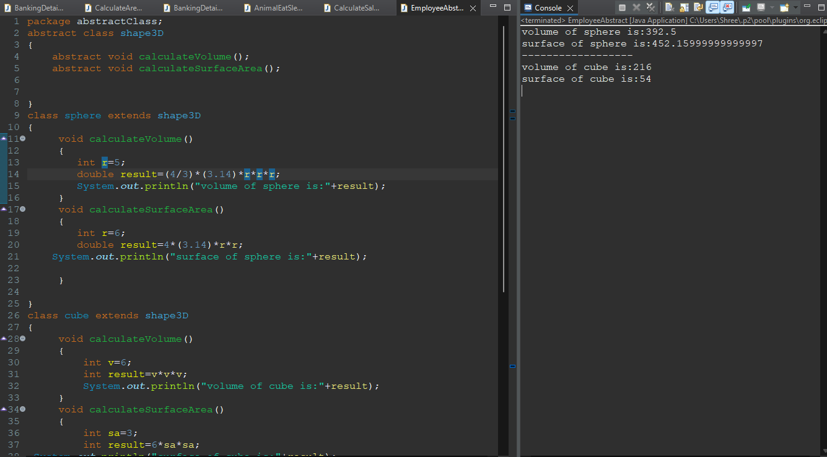

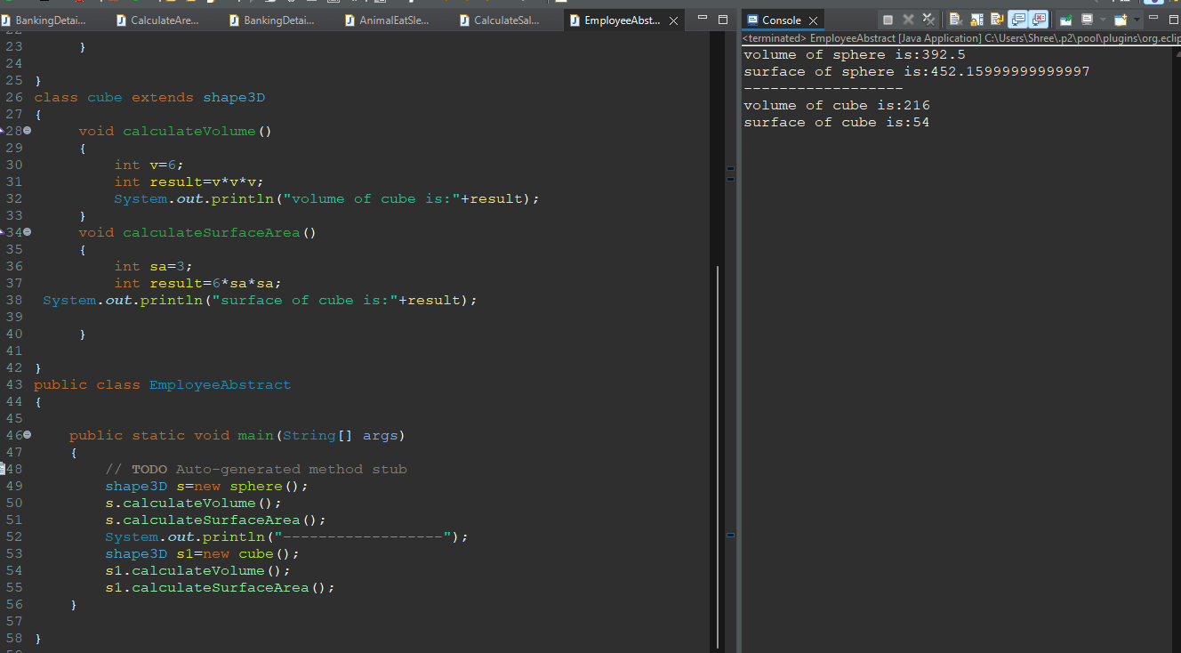

**Interface:**

**1. Write a Java program to create an interface Shape with the getArea() method. Create three classes Rectangle, Circle, and Triangle that implement the Shape interface. Implement the getArea() method for each of the three classes.**

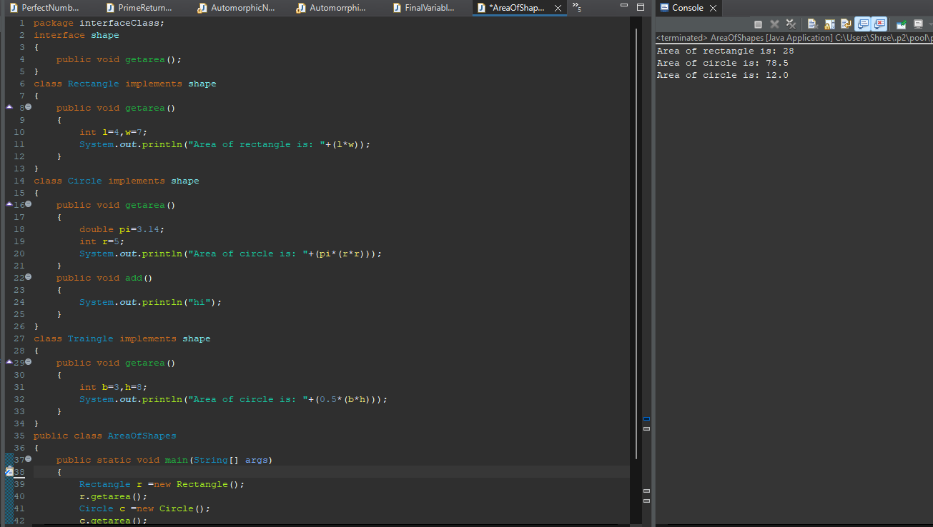

**2. Write a Java program to create a Animal interface with a method called bark() that takes no arguments and returns void. Create a Dog class that implements Animal and overrides speak() to print "Dog is barking".**

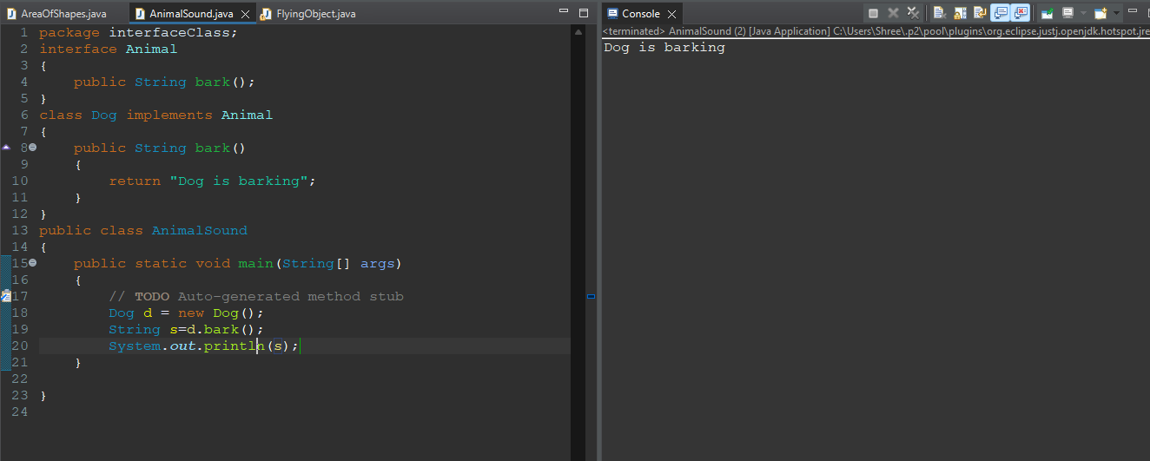

**3. Write a Java program to create an interface Flyable with a method called fly obj(). Create three classes Spacecraft, Airplane, and Helicopter that implement the Flyable interface. Implement the fly_obj() method for each of the three classes.**

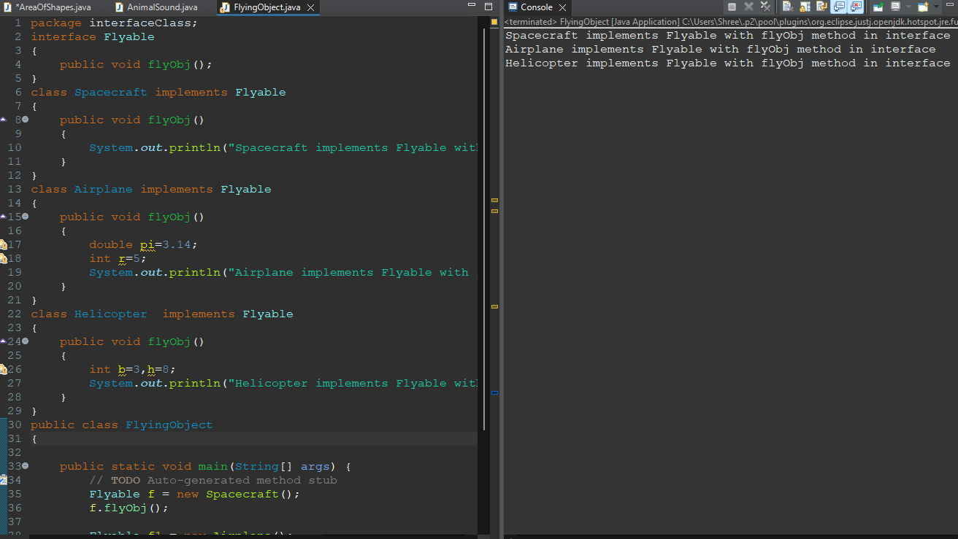 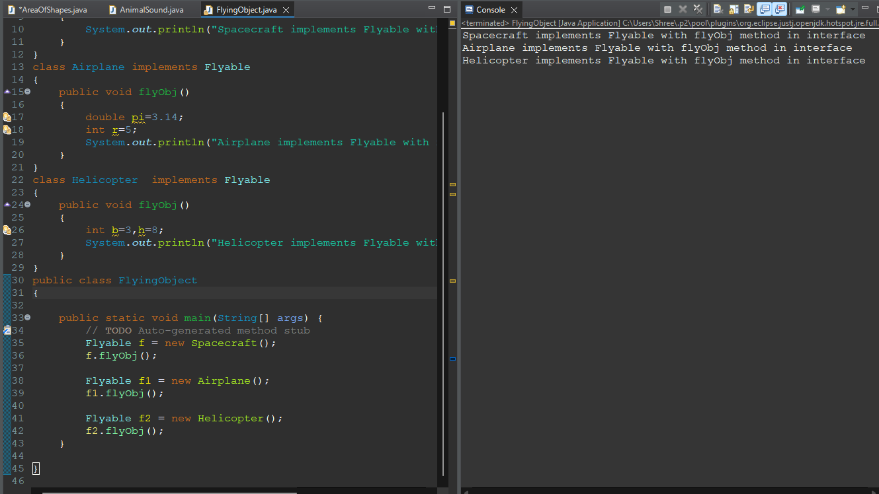

**4. Write a Java programming to create a banking system with three classes - Bank, Account, SavingsAccount, and CurrentAccount. The bank should have a list of accounts and methods for adding them. Accounts should be an interface with methods to deposit, withdraw, calculate interest, and view balances. SavingsAccount and CurrentAccount should implement the Account interface and have their own unique methods.**

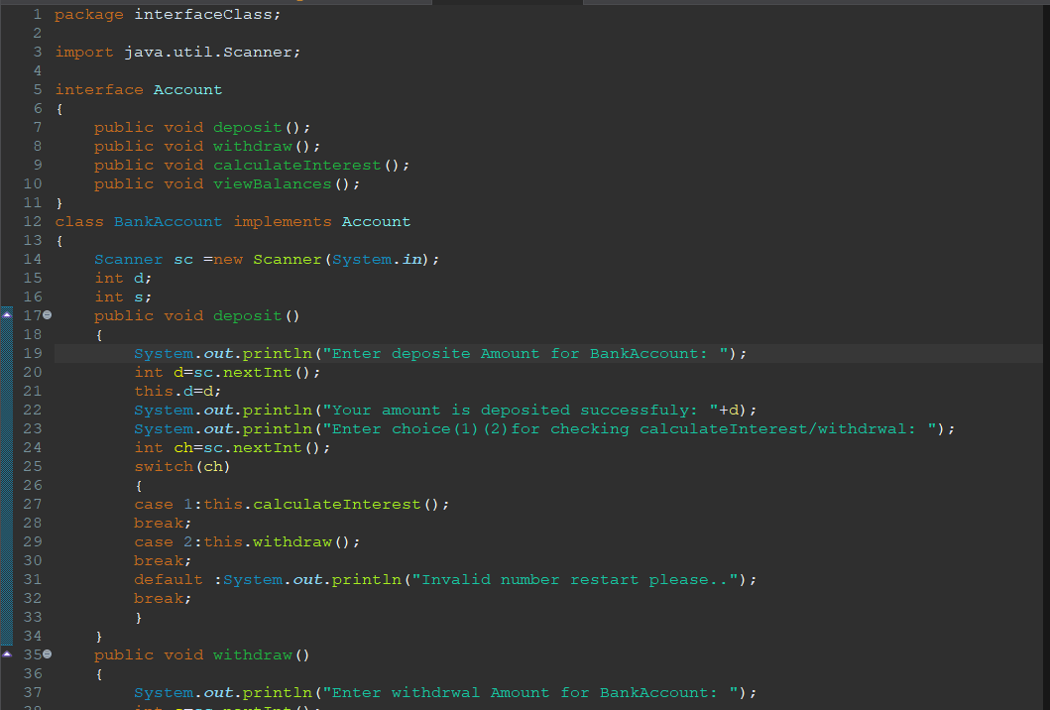

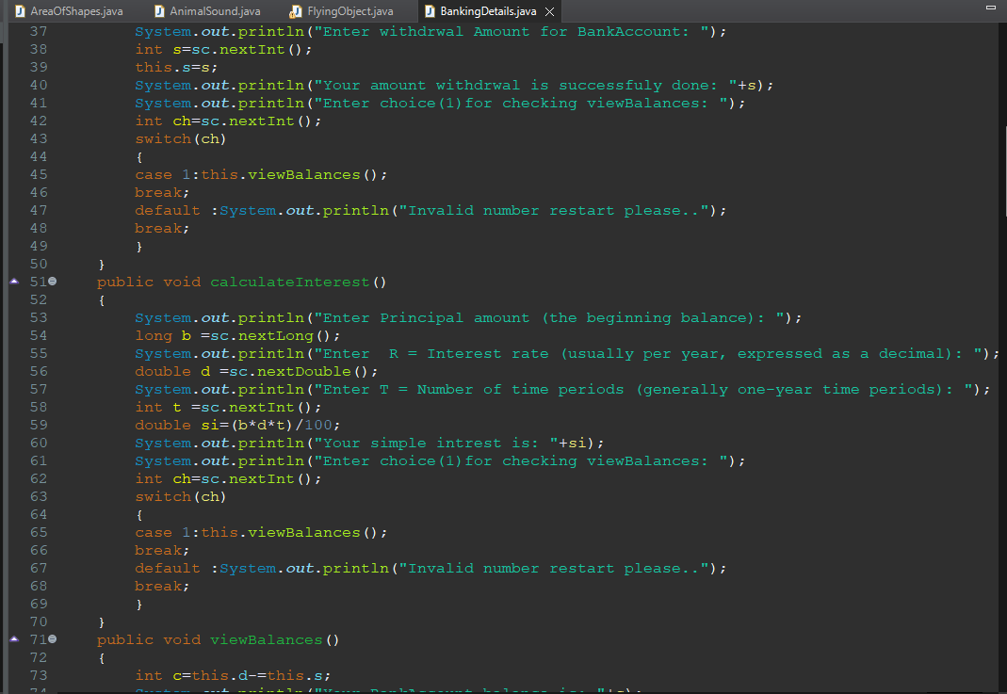

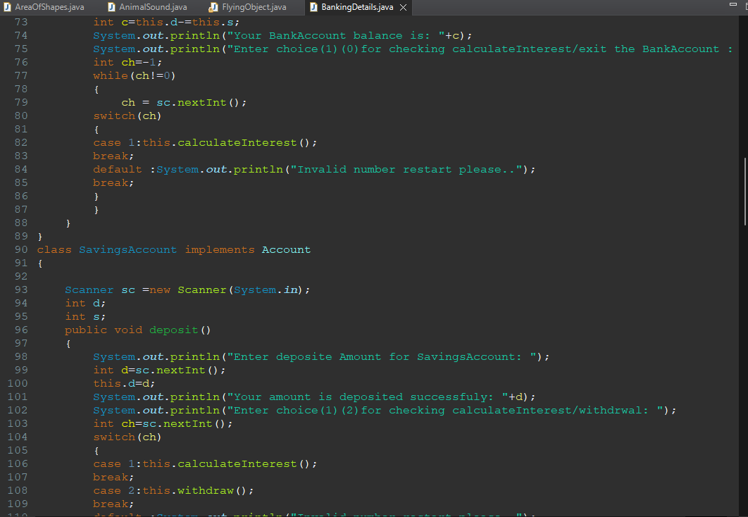

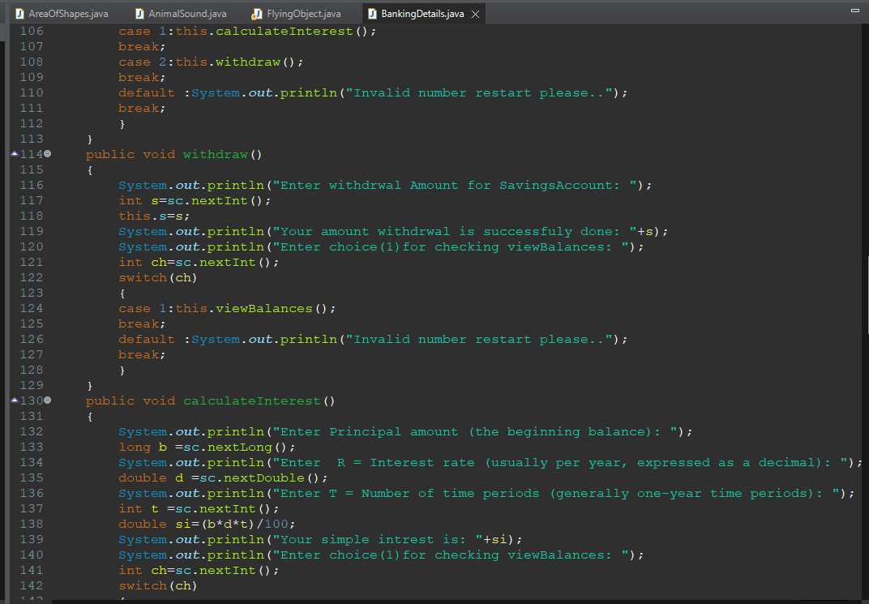

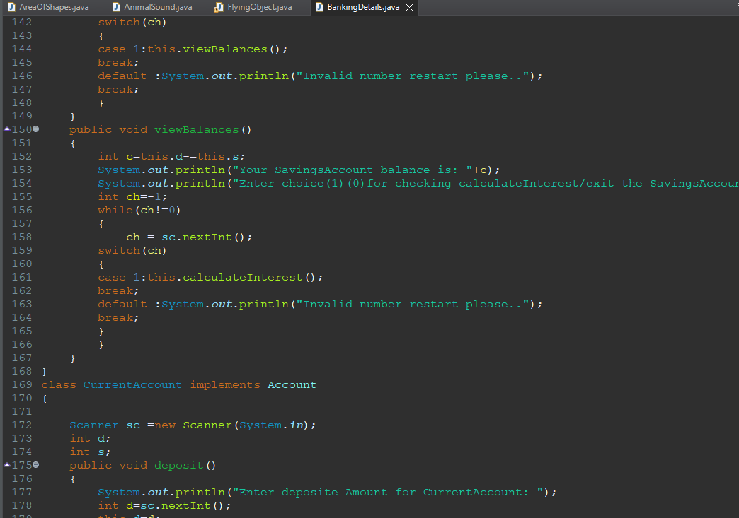

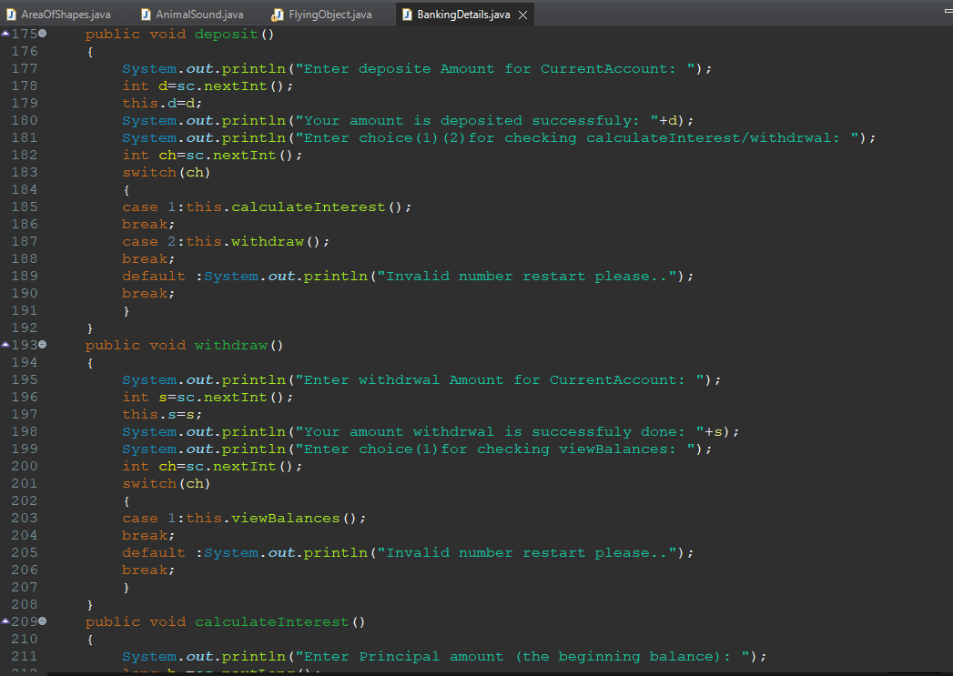

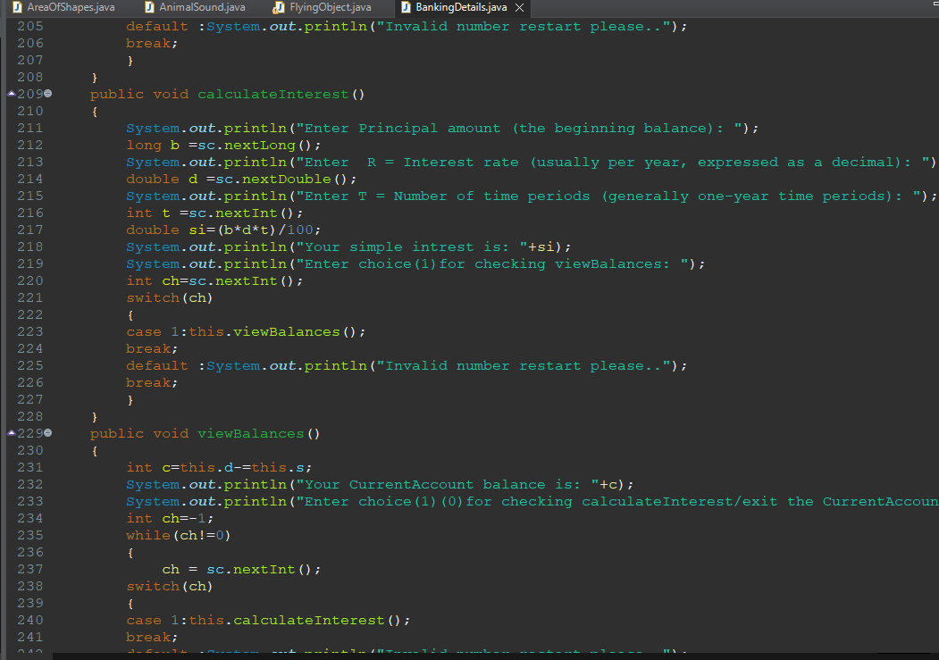

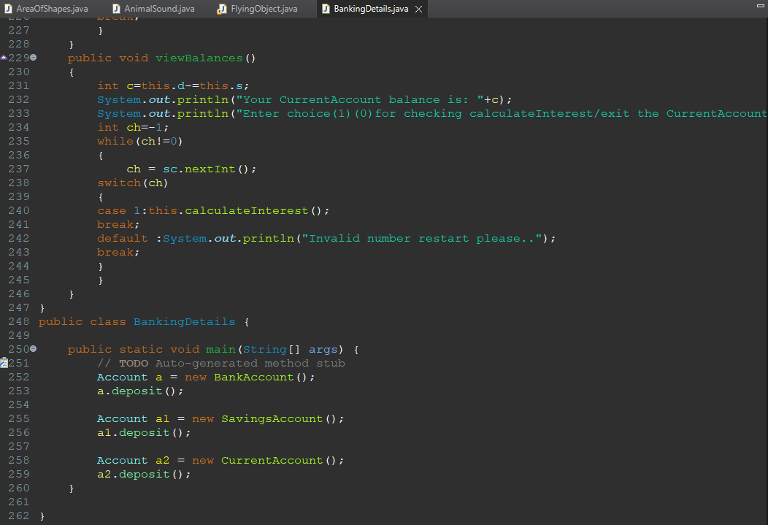

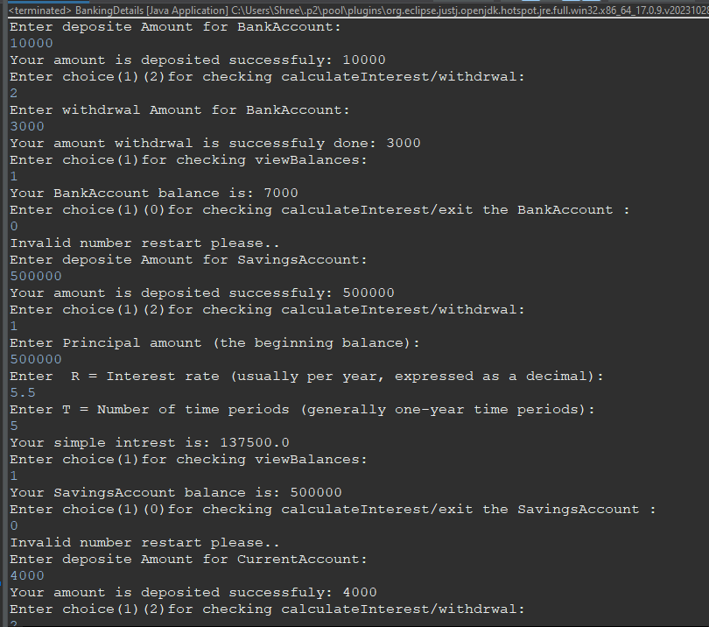

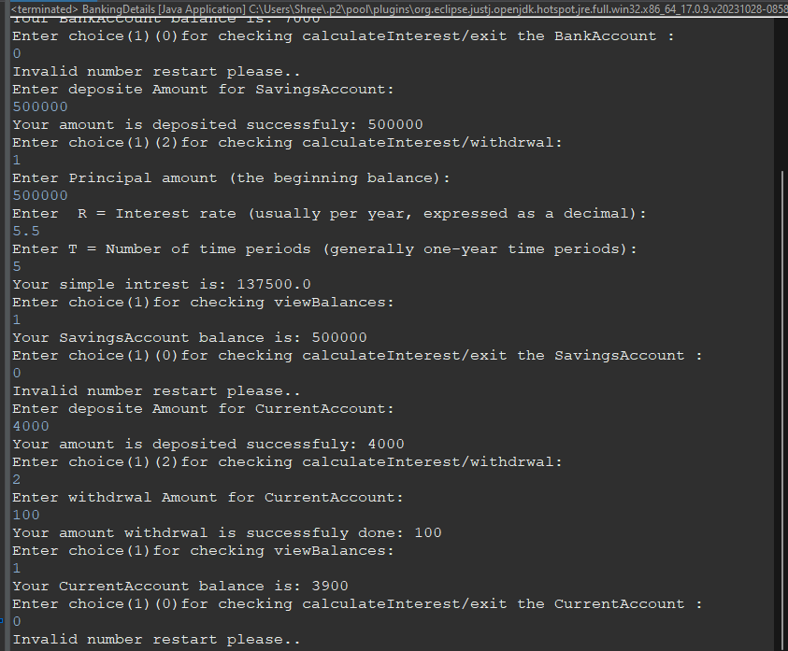

**5. Write a Java program to create an interface Resizable with methods resizeWidth(int width) and resizeHeight(int height) that allow an object to be resized. Create a class Rectangle that implements the Resizable interface and implements the resize methods.**

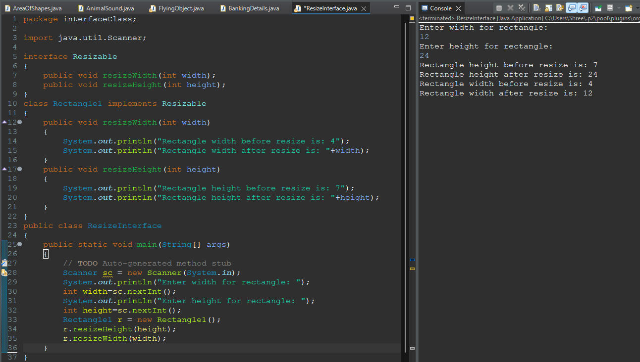

**6. Write a Java program to create an interface Drawable with a method draw() that takes no arguments and returns void. Create three classes Circle, Rectangle, and Triangle that implement the Drawable interface and override the draw() method to draw their respective shapes.**

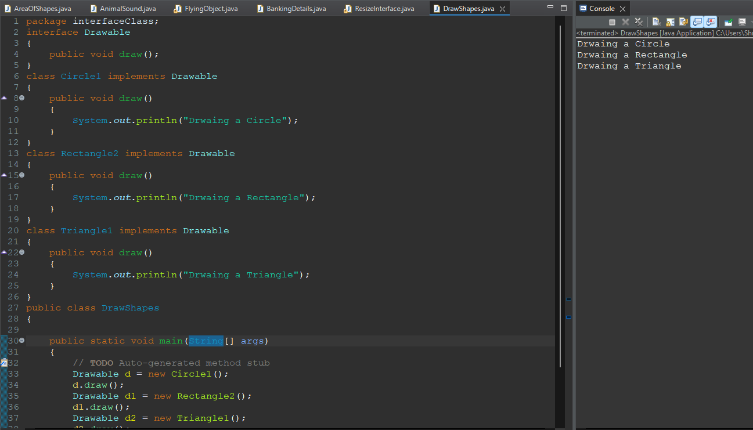 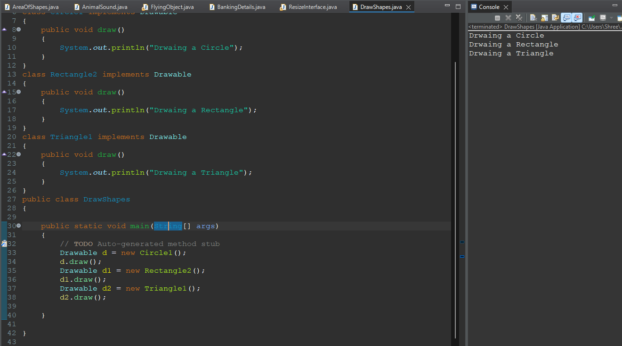

**7. Write a Java program to create an interface Playable with a method play() that takes no arguments and returns void. Create three classes Football, Volleyball, and Basketball that implement the Playable interface and override the play() method to play the respective sports.**

